Diabetes, Mental Health and Corona Virus:
Top tips from Diabetes Care for You
Isolation and quarantine can affect our wellbeing.
Below are very important measures to take:
Keep mentally and physically active and make a plan as both offset low mood and worry.
Put your plan in to diary form and stick to the plan!
AND KEEP TO A ROUTINE TO SUPPORT SLEEP HYGIENE!

Be active (physical fitness)
- Plan an exercise and stretching routine daily – preferably in the morning and at tea time (movement improves our mood as it releases feel good chemicals in our bodies and helps our brains function and we become more mentally motivated too).

- Be productive – do the chores that never get done: clear out cupboards, the garage, the shed. Weed the garden (research shows that positive people do not get depressed and see difficult times as opportunities).

- If you are isolated with other family members, draw up a list of tasks and get everyone involved so you are working together as a team and supporting one another.
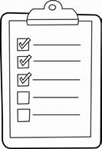

- If you are with children they may get bored. Give them time focused tasks to do and things to make including physical games to play at home. Research has shown that boredom in children can lead to imaginative play and creativity.
Be active (mental fitness)
The National Academy of Sciences states that mental fitness is key to offsetting emotional difficulties:
Take your isolation as an opportunity to:
- Learn something new or brush up on a language for example!

- Play Sudoku / crosswords to stimulate parts of the brain which reduce anxiety.
- Be creative, bake bread or fix broken items in the home.
- Keep on the phone to family and friends use Skype, facetime or other forms of interactive social media if you have it to ‘see’ family and friends and make sure you are involved in supporting others who are also quarantined and living alone.
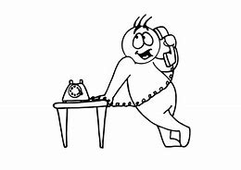
Don’t worry!
You are not alone in the world.

